Basic Wireshark Lab

Ryan Coon

CYB-505

Professor Devin Ogg

July 31, 2024

Part 1

Screenshots:

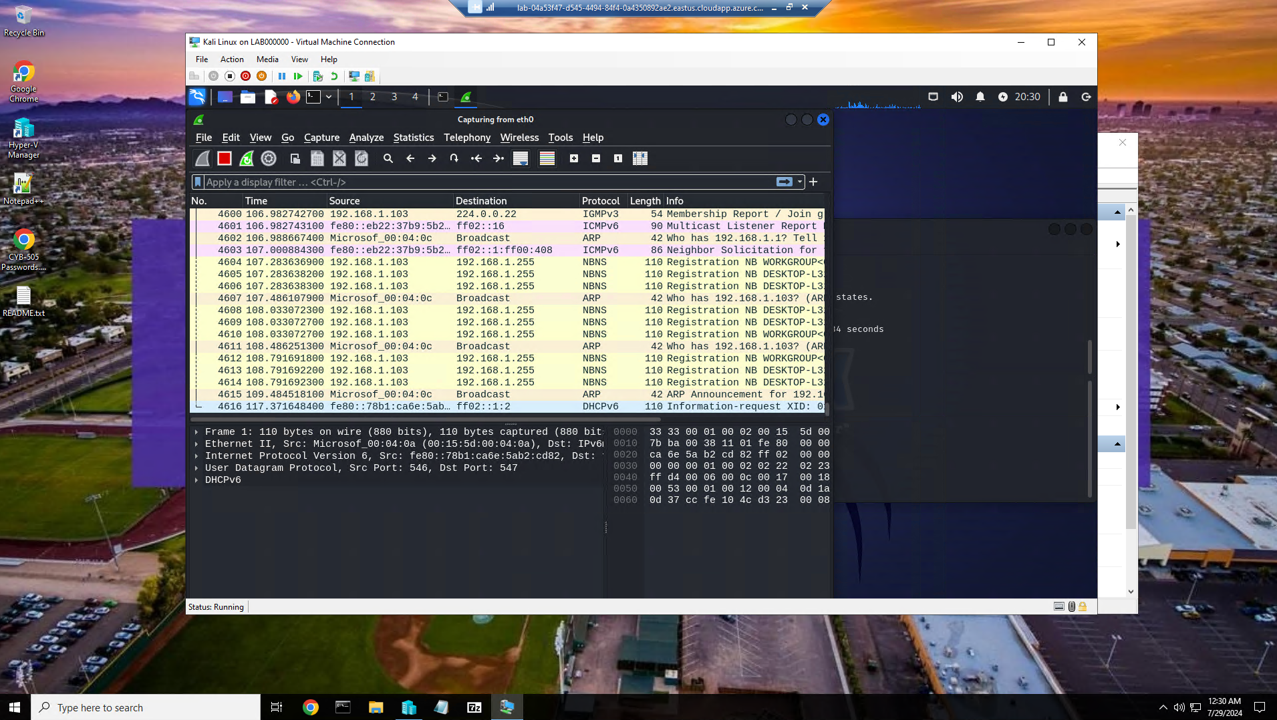

Wireshark packet capture showing all network traffic.

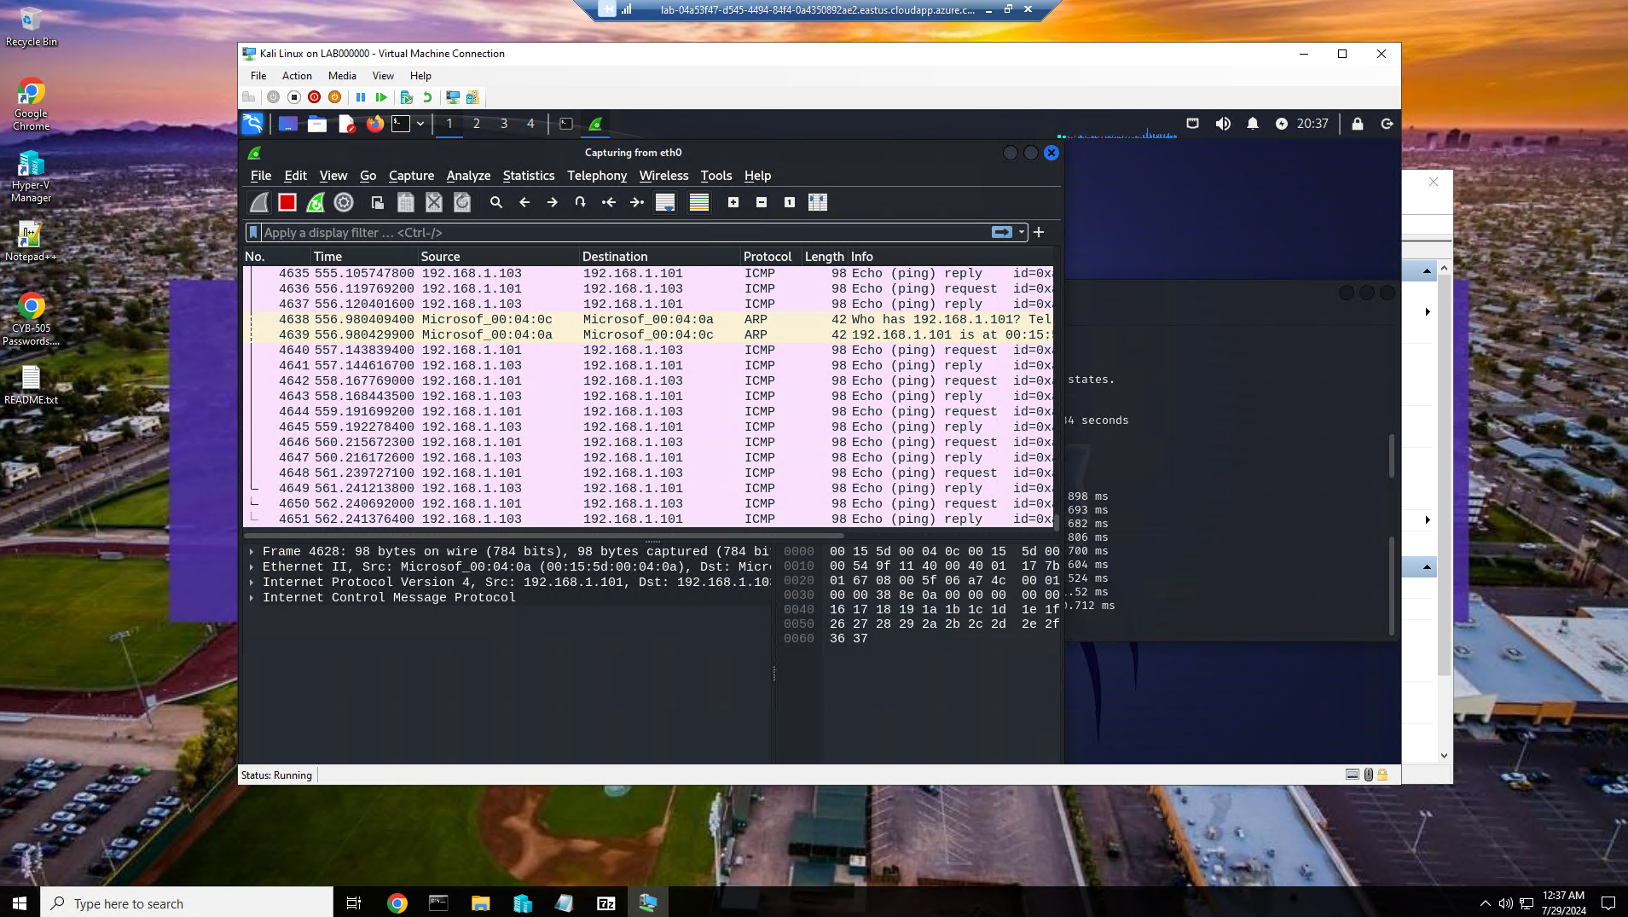

Here we pinged the Windows 10 server from Kali to show the traffic between the two. Kali ip is 192.168.1.101 and the windows 10 ip is 192.168,1,103.

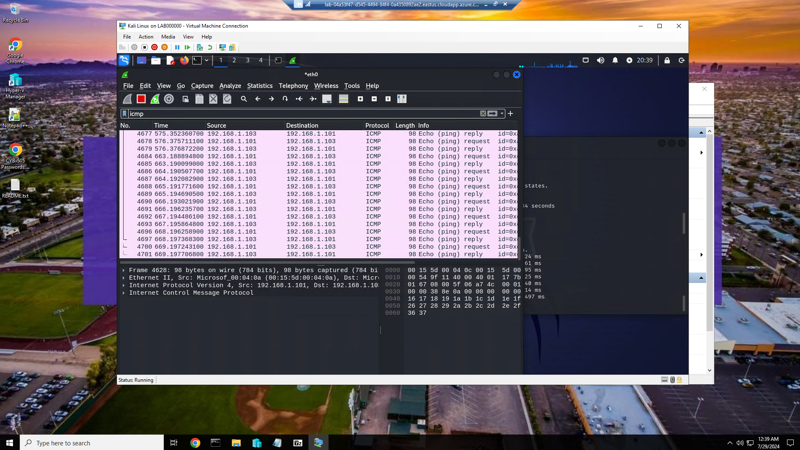

Here wi pinged the Windows 10 server with the icmp filter applied on wireshark.

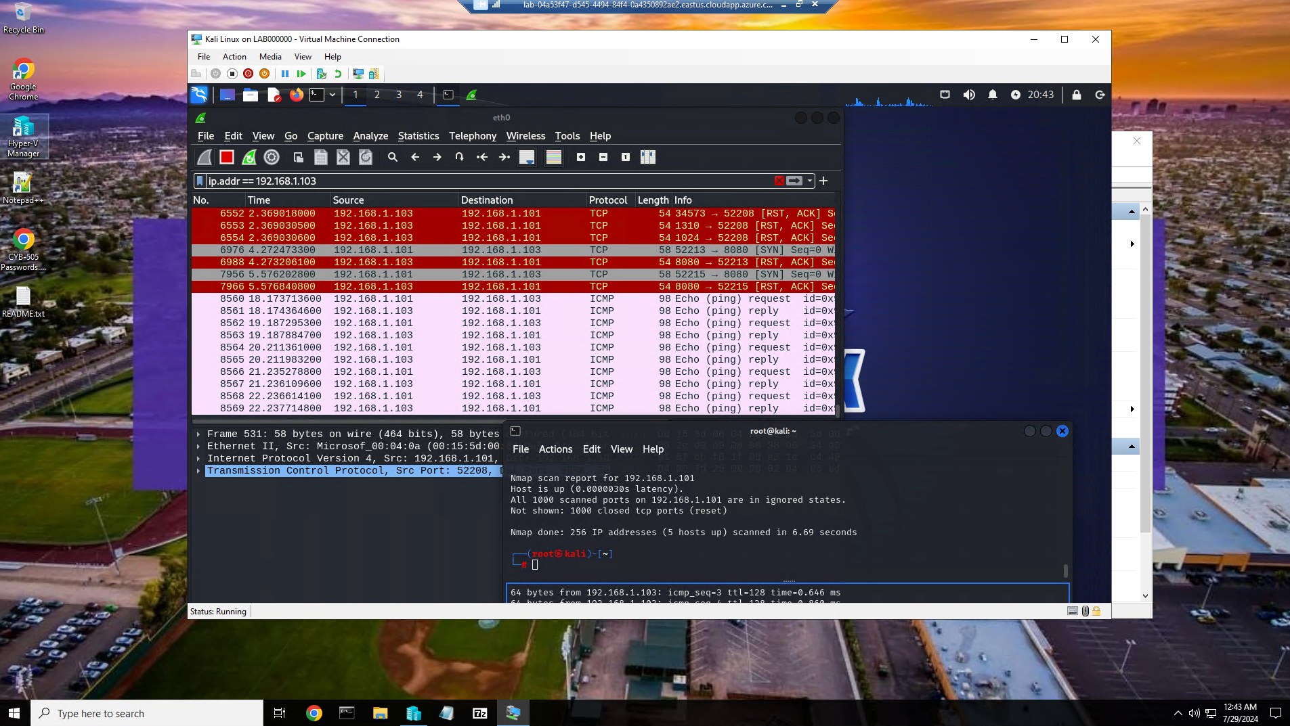Here we applied the Windows 10 ip address as the filter and ran the nmap.

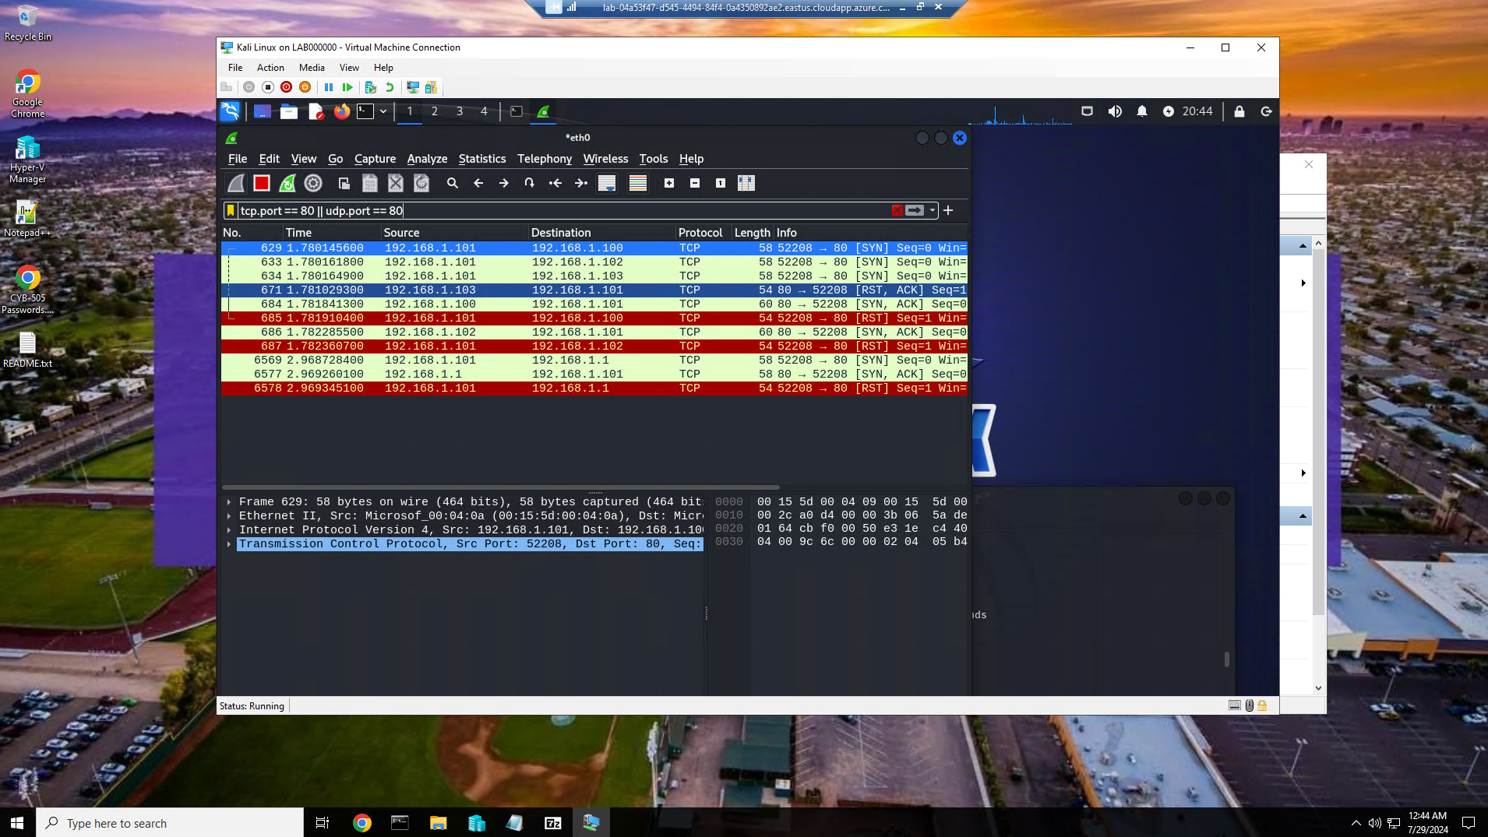

We ran the filter to filter traffic on tcp port 80 only.

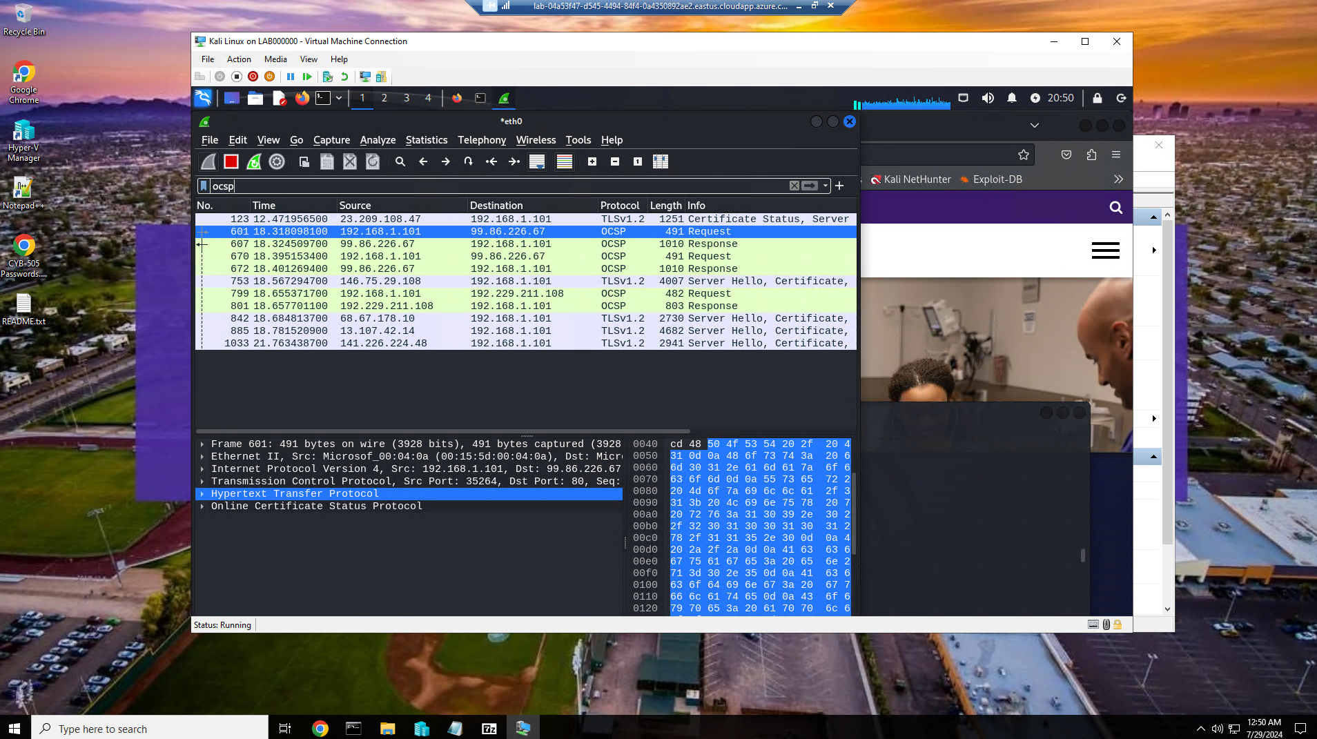

Here we applied a filter to isolate traffic with OCSP or Online Certificate Status Protocols.

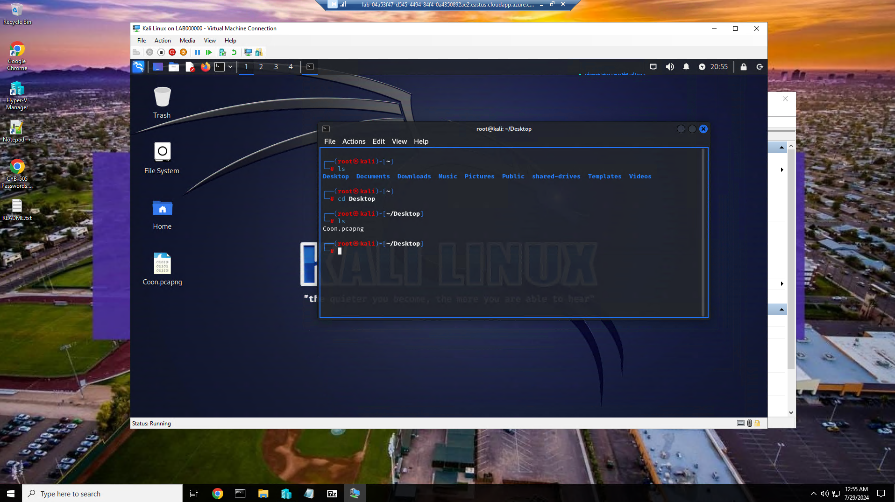

Here is the saved package capture saved to desktop.

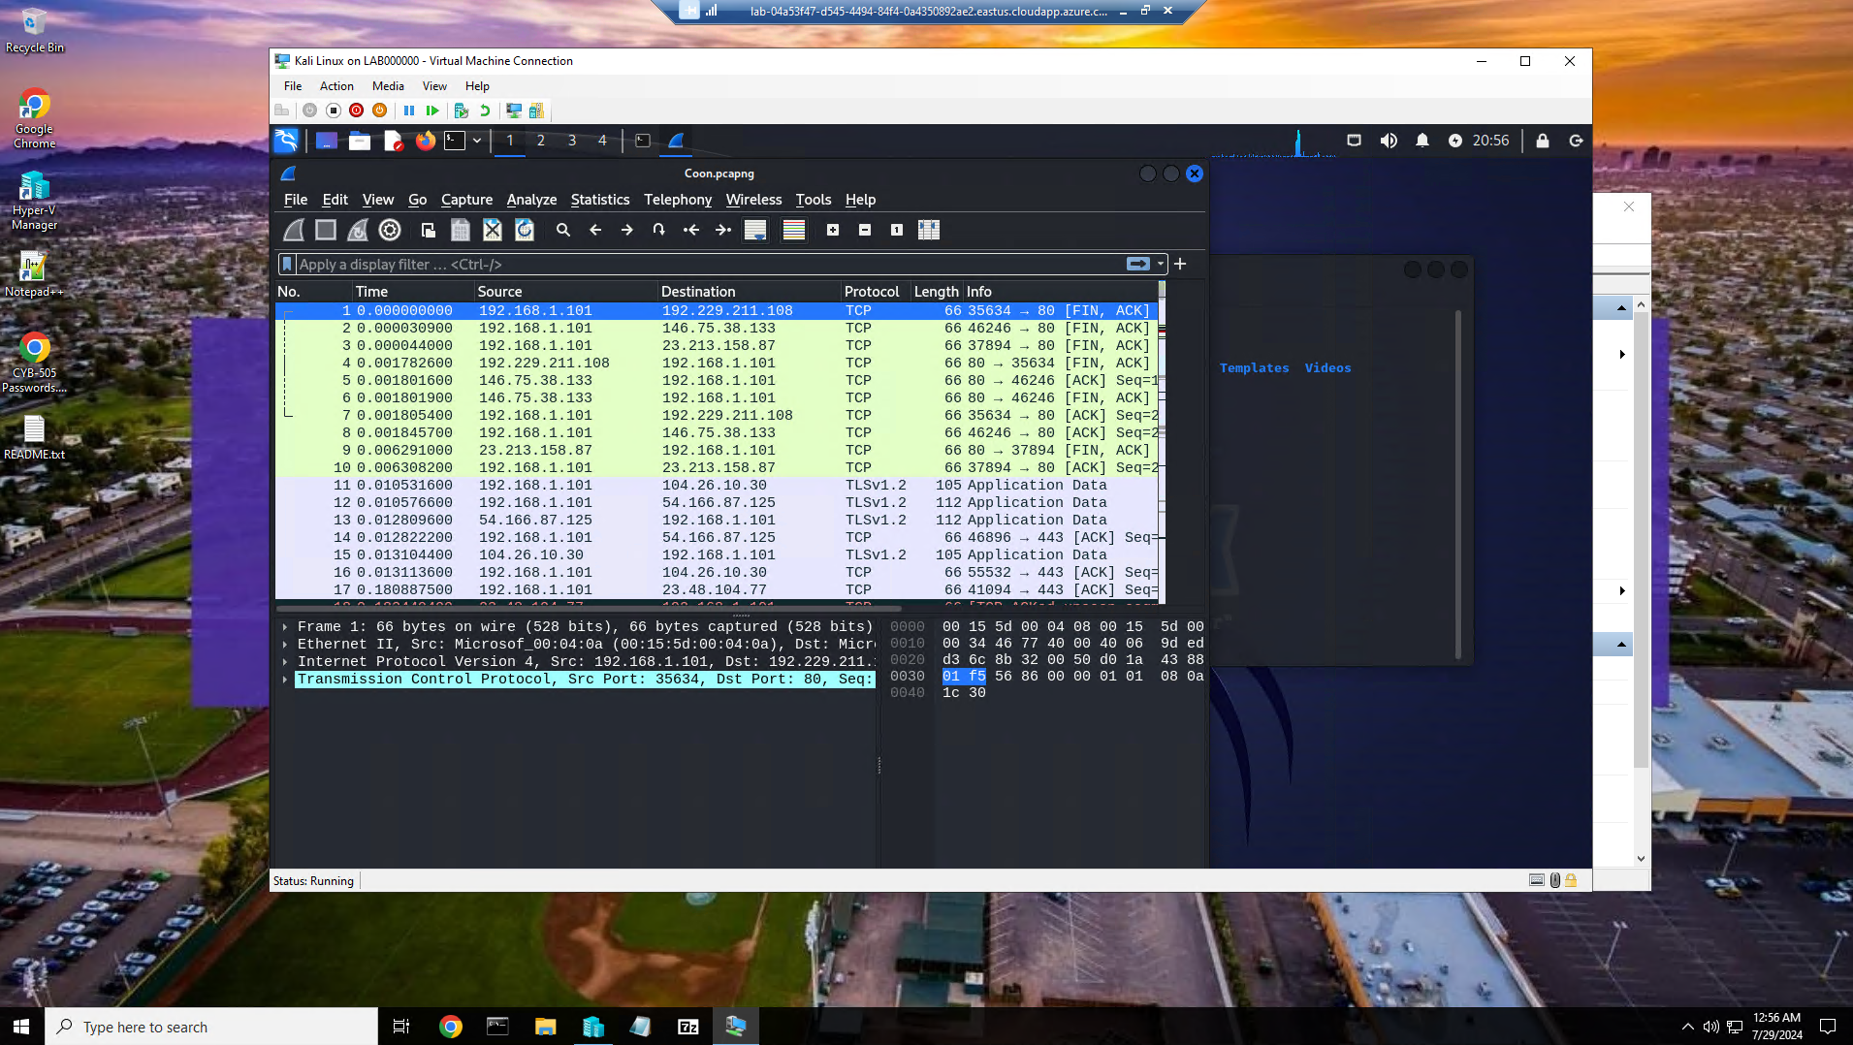

Here is the above saved packet file opened and loaded into wireshark.

Part 2

**Your Kali IP address.**

In the command line of our Kali VM server I entered ipaddr to identify my Kali Linux ip address. The ip address for my Kali Linux VM server is 192.168.1.101.

**The Windows IP Address.**

In command prompt, I entered ipconfig /all to identify my Windows 10 ip address. The ip address for my Windows 10 VM is 192.168.1.103.

**For both Windows and Linux, identify and explain the following commands:**  
 Command used to change directory/folder - The cd command is used to change the current working directory in Windows Command Prompt or PowerShell and in the Linux terminal.  
 Command that moves a file - For windows the command is move and Linux the command is mv. The command is used to move files from one location to another.  
 Command that removes a file – In windows the command is either del or erase. In Linux the command is rm. These commands are used to remove or delete a file in their respective operating system.  
 Command that creates a new directory/folder – In both Windows and Linux the command is mkdir. The mkdir command is used to create a new directory or folder in Linux and Windows.

**An explanation for why a timestamp is important on Wireshark, as well as other logging tools.**

Timestamps are essential in Wireshark and logging tools as they provide a chronological reference point for network activities, aid in troubleshooting network issues, enable performance analysis, support security investigations, ensure compliance with regulations, and facilitate synchronization across diverse systems. Accurate timestamps are foundational for effective network analysis, monitoring, and incident response in both operational and security contexts.

**A list of 10 well-known ports and associated protocols.**

Here is a list of some well-known ports and protocols commonly associated with them

|  |  |
| --- | --- |
| Port Number | Protocol |
| 80 | HTTP |
| 443 | HTTPS |
| 22 | SSH |
| 21 | FTP |
| 25 | SMTP |
| 110 | POP3 |
| 143 | IMAP |
| 53 | DNS |
| 3389 | RDP |
| 1194 | OpenVPN |

**A brief explanation of the difference between a port and a protocol.**

Port - Acts as a specific endpoint for communication, directing network traffic to specific applications or services.

Protocol - Defines the rules and standards for communication and data exchange between devices on a network.

**Describe how Wireshark can be used to identify events that indicate an attack is in progress or has happened.**

Wireshark is a powerful network protocol analyzer that can be used in identifying events that indicate a network attack is in progress or has occurred. Wireshark can be used for anomaly detection, traffic analysis, connection analysis, DNS analysis, traffic encryption, signature detection, behavioral analysis, alerts and notifications, packet reconstruction, and collaboration and reporting.

Anomaly Detection:

Unusual Traffic Patterns: Monitor network traffic for sudden spikes, unusual patterns, or unexpected protocols that may indicate a potential attack.

Unknown Source or Destination: Look for traffic coming from or going to unknown IP addresses or unusual ports.

Traffic Analysis:

Malicious Payloads: Analyze packet contents for suspicious payloads such as malware signatures, command injections, or unusual file transfers.

Protocol Violations: Detect any deviations from standard protocols that could indicate an attempt to exploit vulnerabilities.

Connection Analysis:

Multiple Failed Connection Attempts: Identify repeated failed connection attempts, which could be a sign of a brute force attack.

Abnormal Connection Behavior: Look for connections to known malicious IPs or domains.

DNS Analysis:

Domain Resolution: Monitor DNS requests for unusual domain names that could be associated with command and control servers or malicious websites.

Traffic Encryption:

Decryption: If possible, decrypt encrypted traffic to inspect the contents for signs of malicious activity.

Signature Detection:

Known Attack Signatures: Use Wireshark in conjunction with threat intelligence feeds or known attack signatures to identify patterns associated with specific attacks.

Behavioral Analysis:

Baseline Traffic: Establish a baseline of normal network behavior and look for deviations that might indicate an attack.

Alerts and Notifications:

Set Alerts: Configure Wireshark to trigger alerts based on predefined criteria, such as specific packet patterns or traffic anomalies.

Packet Reconstruction:

Reconstruct Packets: Piece together fragmented packets to analyze the complete data flow, enabling a comprehensive view of network activity.

Collaboration and Reporting:

Share Findings: Collaborate with security teams by sharing packet captures for further analysis and incident response.

Generate Reports: Create detailed reports documenting the identified events, attack indicators, and recommended actions.

References:

*50 Common Ports You Should Know*. (2022, February 25). GeeksforGeeks. https://www.geeksforgeeks.org/50-common-ports-you-should-know/

*Considerations for timestamps in centralized logging platforms*. (2020, February 13). Elastic Blog. https://www.elastic.co/blog/considerations-for-timestamps-in-centralized-logging-platforms

*Introduction to command line · HonKit*. (n.d.). Tutorial.djangogirls.org. https://tutorial.djangogirls.org/en/intro_to_command_line/

*Kali Linux Basic Commands - javatpoint*. (n.d.). Www.javatpoint.com. https://www.javatpoint.com/kali-linux-basic-commands

Oda, T. (2022, January 15). *[Wireshark]Cyber security analysis and identify common cyber network attacks*. Medium. https://takahiro-oda.medium.com/wireshark-cyber-security-analysis-and-identify-common-cyber-network-attacks-d4eda3c16333

*Ports and Protocols*. (n.d.). Help.incontact.com. https://help.incontact.com/Content/GlobalFeatures/Connectivity/PortsAndProtocols.htm#:~:text=Ports%20are%20identified%20with%20numeric